Day 9 – 13/06/2025

//Task001: Create an array of size 'n' and  
// try to access the element at the index of 'n+'.  
  
package Exceptions;  
  
public class Task001 {  
 public static void main(String[] args) {  
 int[] num = {1, 2, 3};  
 System.*out*.println(num[5]);  
 }  
}

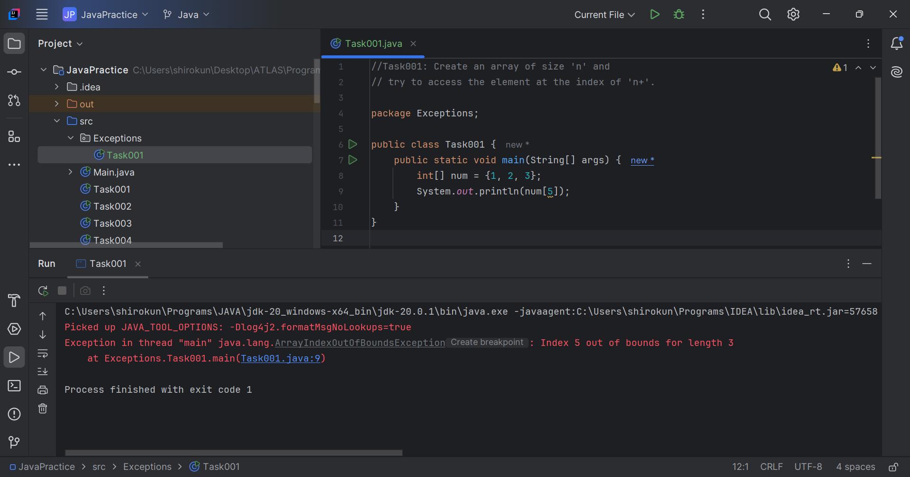

//Task002: Include try catch blocks.  
  
package Exceptions;  
  
public class Task002 {  
 public static void main(String[] args) {  
 try {  
 int[] num = {1, 2, 3};  
 System.*out*.println(num[5]);  
 }catch (Exception e){  
 System.*out*.println("Something went wrong!! ");  
 }  
 }  
}

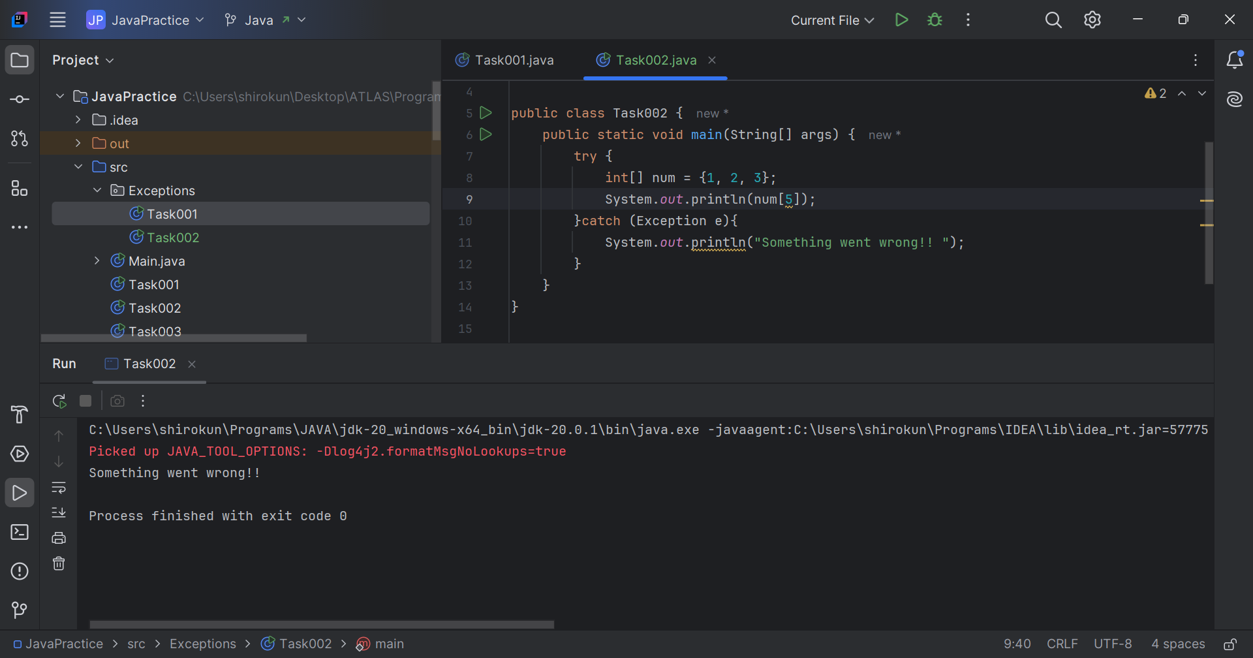

//Task003: Include finally block.  
  
package Exceptions;  
  
public class Task003 {  
 public static void main(String[] args) {  
 try {  
 int[] num = {1, 2, 3};  
 System.*out*.println(num[5]);  
 }catch (Exception e){  
 System.*out*.println("Something went wrong!! ");  
 }finally {  
 System.*out*.println("This is from finally block.");  
 }  
 }  
}

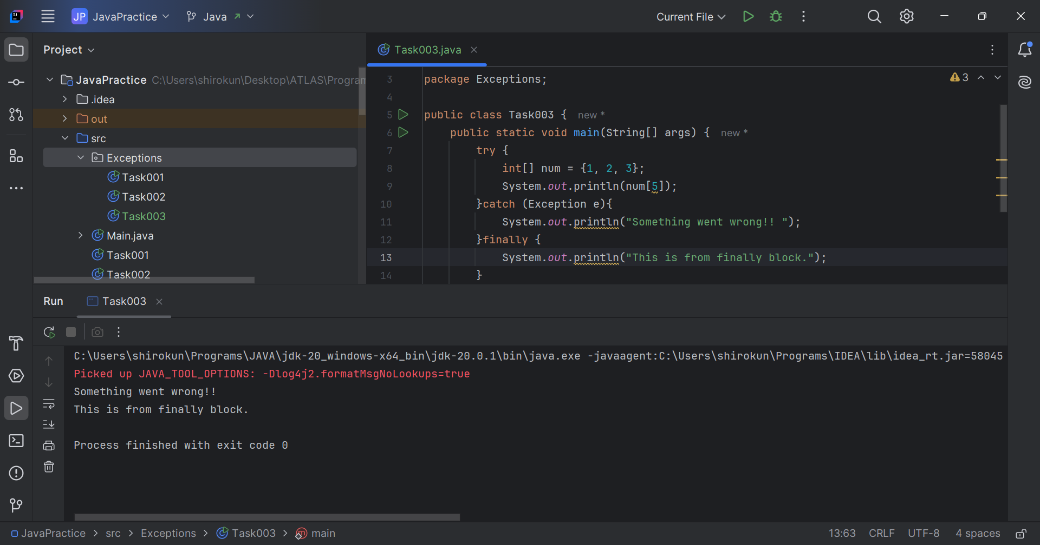

//Task004: Accessing elements of the array.  
  
package Exceptions;  
  
public class Task004 {  
 public static void main(String[] args) {  
 try {  
 int[] num = {1, 2, 3};  
 System.*out*.println(num[2]+"\n"+num[1]);  
 }catch (Exception e){  
 System.*out*.println("Something went wrong!! ");  
 }finally {  
 System.*out*.println("This is from finally block.");  
 }  
 }  
}

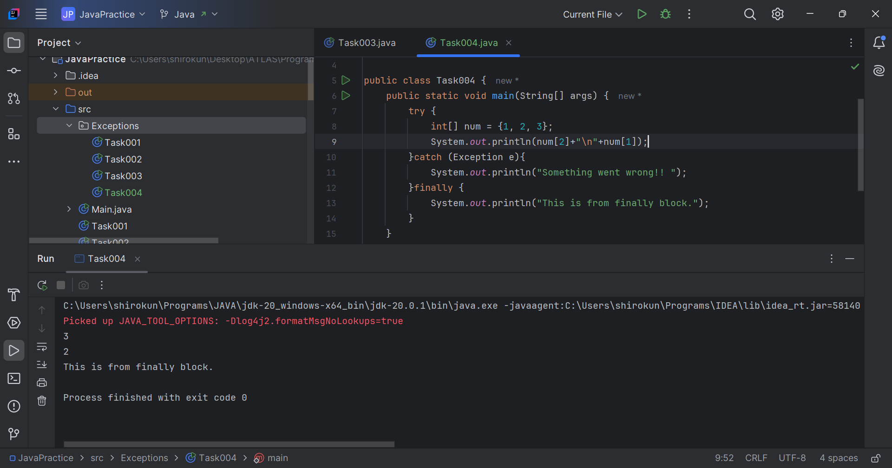

// Task005: Try multiple catch blocks.  
  
package Exceptions;  
  
public class Task005 {  
 public static void main(String[] args) {  
 try{  
 int[] arr = new int[7];  
 int a = 5, b = 0, c;  
 c = a / b;  
 arr[c + 10] = 10;  
 System.*out*.println(c + arr[10]);  
 }catch (ArrayIndexOutOfBoundsException e){  
 System.*out*.println("Index out of bounds: "+ e);  
 }catch (Exception e){  
 System.*out*.println("Exception thrown: "+ e);  
 }finally {  
 System.*out*.println("Finally");  
 }  
 }  
}

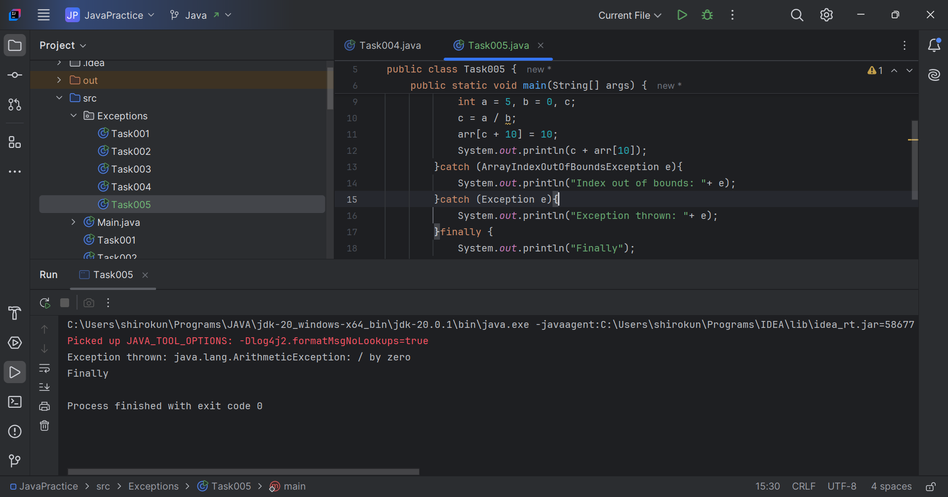

// Task006: Nested try blocks.  
  
package Exceptions;  
  
public class Task006 {  
 public static void main(String[] args) {  
 try {  
 int[] a = new int[2];  
// System.out.println("Access element three :" + a[2]);  
 System.*out*.println("Access element three :" + a[1]);  
 try {  
 int b = 0;  
 int c = 1/b;  
 }catch(Exception e) {  
 System.*out*.println("Exception thrown: " + e);  
 }  
 System.*out*.println("Access element three :" + a[3]);  
 }  
 catch (ArrayIndexOutOfBoundsException e) {  
 System.*out*.println("Exception thrown: " + e);  
 }  
 System.*out*.println("Out of the block");  
 }  
}

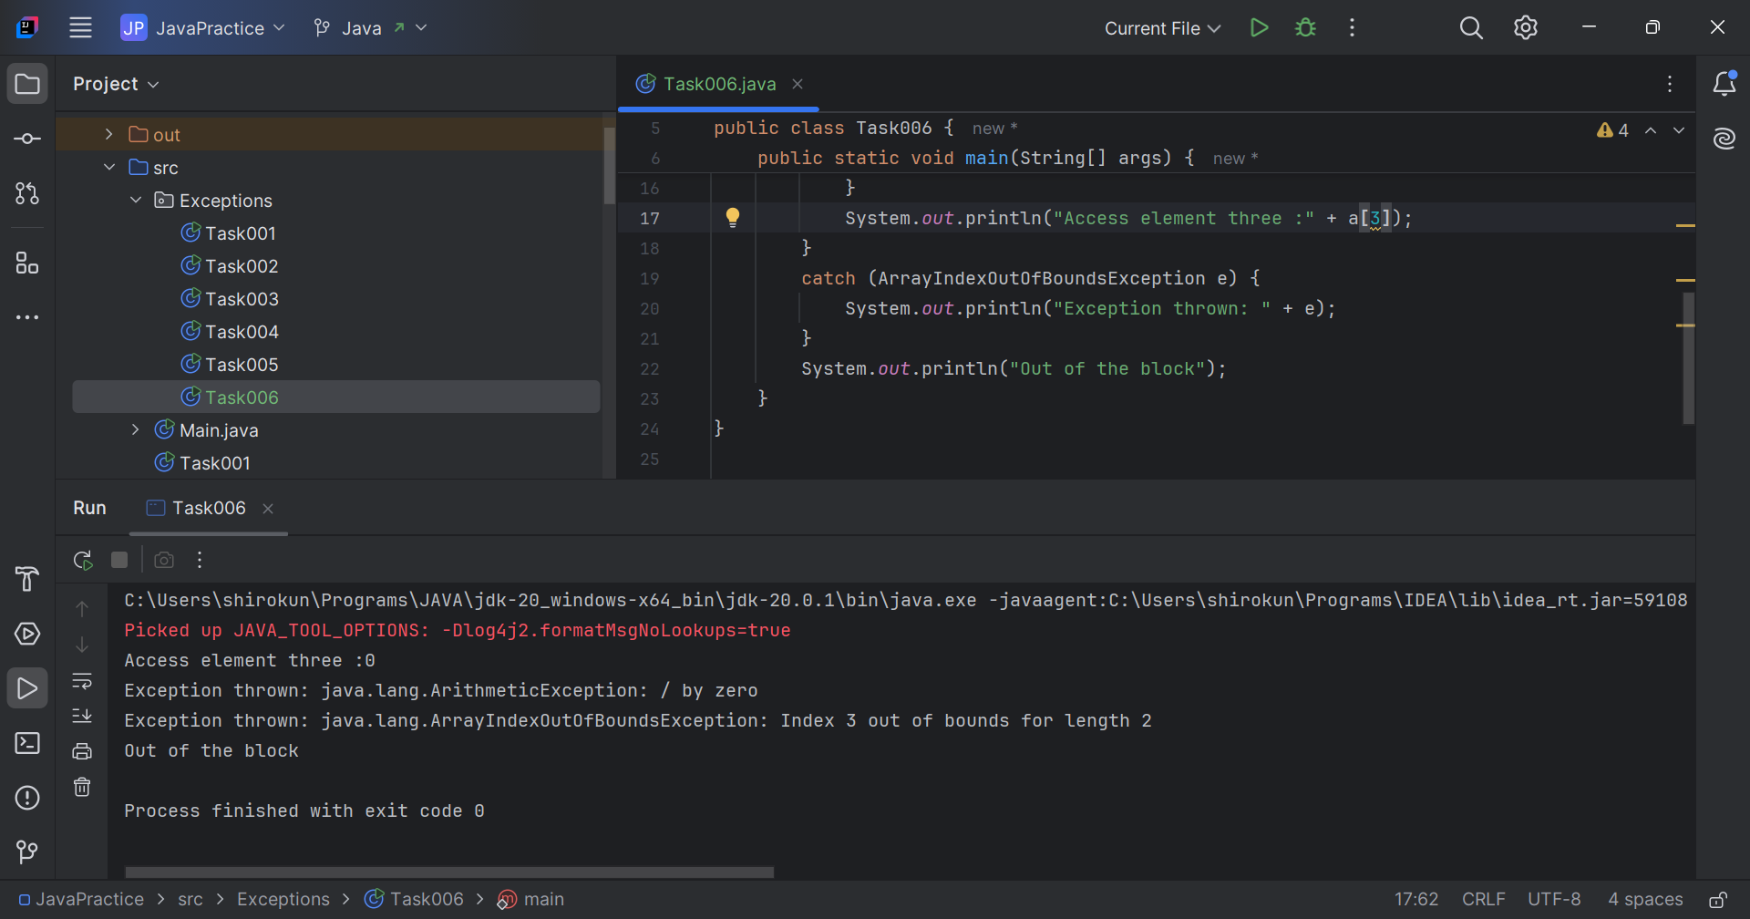

// Task007: Throw an exception.  
  
package Exceptions;  
  
public class Task007 {  
  
 static void fun(int a, int b){  
 if (b == 0){  
 throw new ArithmeticException("Division by zero exception.");  
 }  
 }  
  
 public static void main(String[] args) {  
 int a=4, b=0;  
 try {  
 *fun*(a, b);  
 } catch (Exception e) {  
 System.*out*.println(e);  
 }  
 }  
}

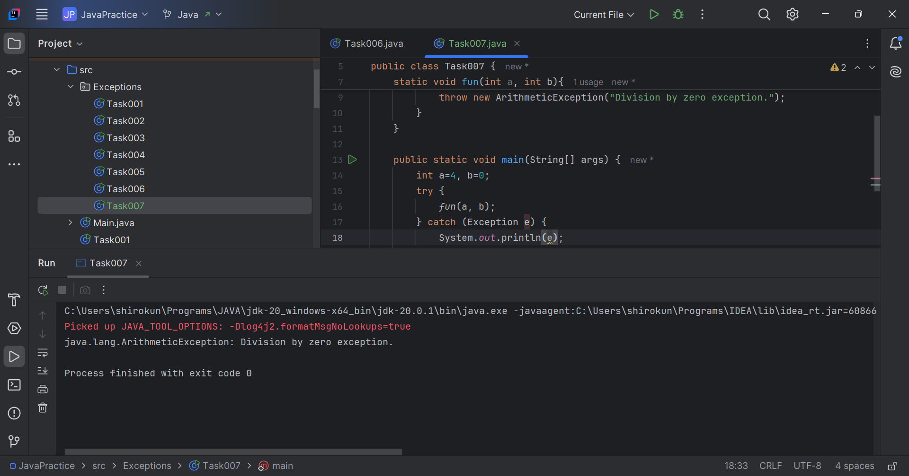

// Task008: Custom exceptions.  
  
package Exceptions;  
  
class MyException extends Exception {  
 public MyException(String m) {  
 super(m);  
 }  
}  
  
public class Task008 {  
 public static void main(String[] args) {  
 try {  
 throw new MyException("This is a custom exception");  
 } catch (MyException ex) {  
 System.*out*.println("Caught");  
 System.*out*.println(ex.getMessage());  
 }  
 }  
}

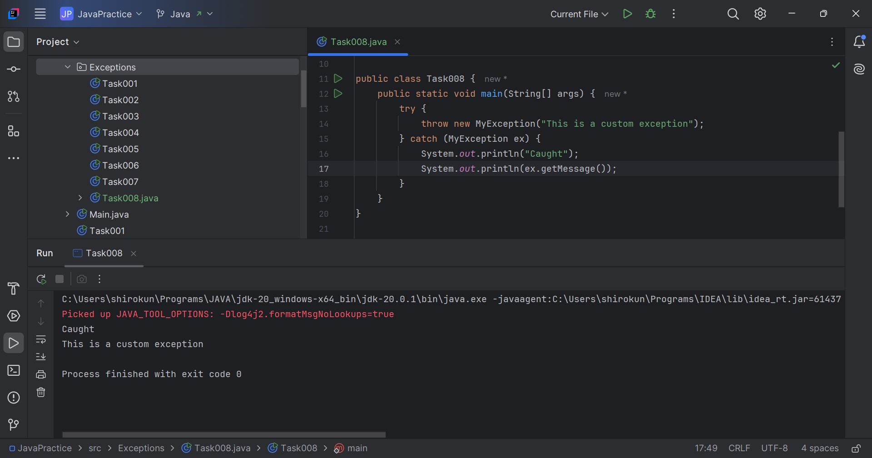

// Task009: Define ArrayLists.  
  
package Collections;  
  
import java.util.ArrayList;  
  
public class Task009 {  
 public static void main(String[] args) {  
 ArrayList<Integer> arrayList = new ArrayList<>();  
 for (int i = 0; i < 5; i++) {  
 arrayList.add(i);  
 }  
 System.*out*.println(arrayList);  
 }  
}

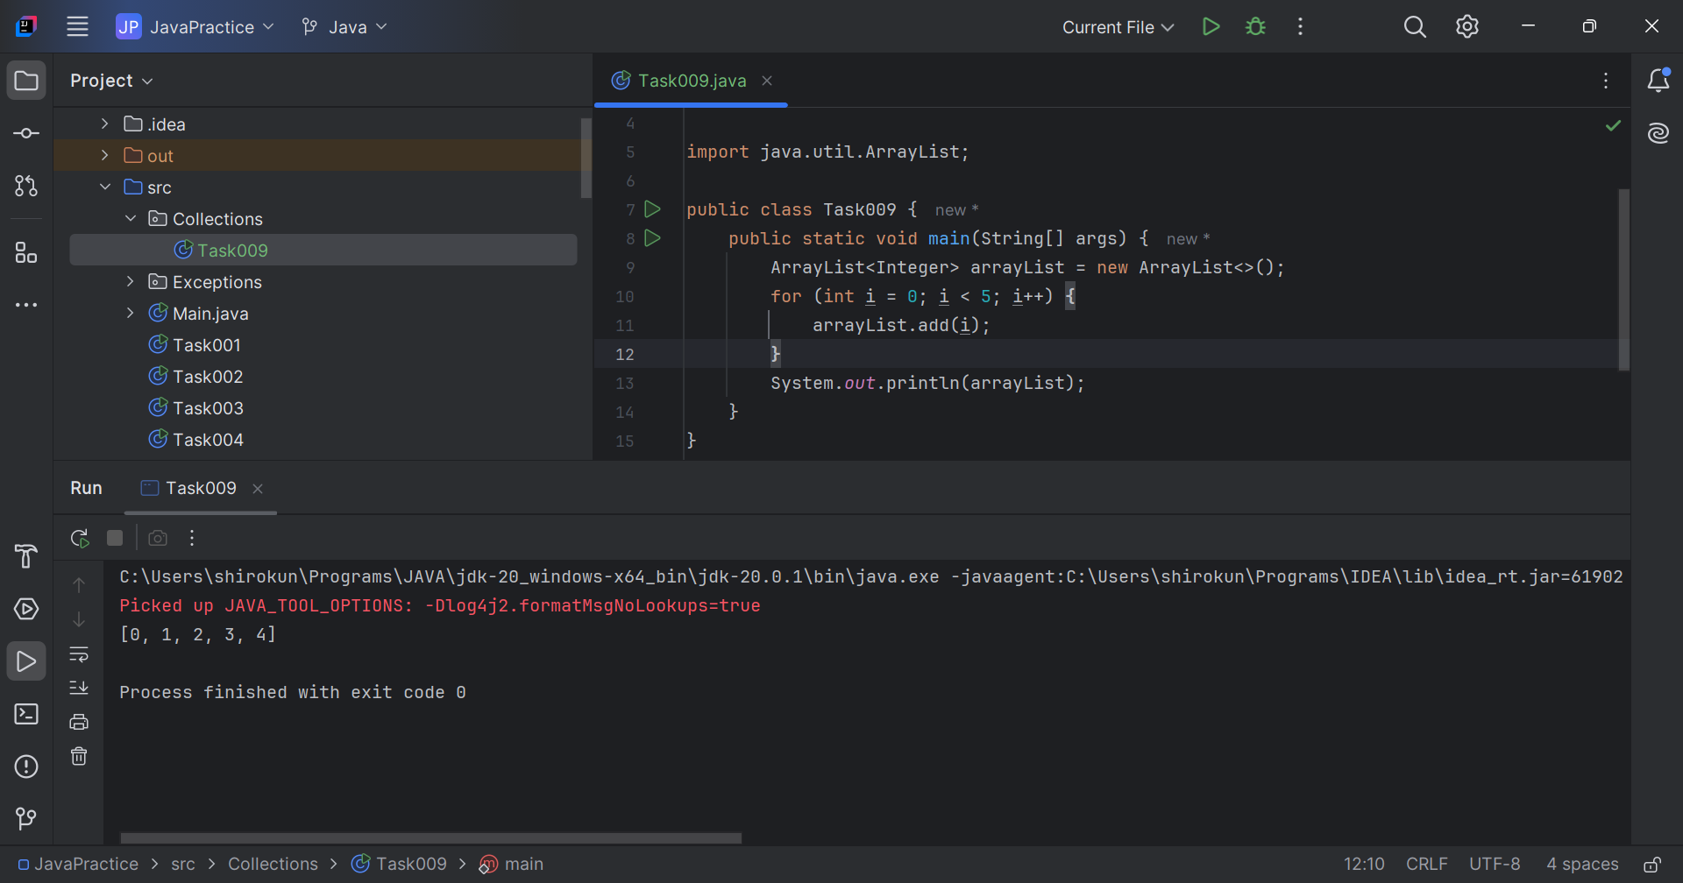

// Task010: add, remove and set methods from ArrayList.  
  
package Collections;  
  
import java.util.ArrayList;  
  
public class Task010 {  
 public static void main(String[] args) {  
 ArrayList<String> al = new ArrayList<>();  
 al.add("shiro");  
 al.add("kunal");  
 System.*out*.println("Original List: "+al);  
  
 al.add(1, "Hello");  
 System.*out*.println("After Adding element at index 1: "+ al);  
  
 al.remove(0);  
 System.*out*.println("Element removed from index 0: "+ al);  
  
 al.remove("kunal");  
 System.*out*.println("Element kunal removed: "+ al);  
  
 al.set(0, "K");  
 System.*out*.println("List after update: "+al);  
  
 }  
}

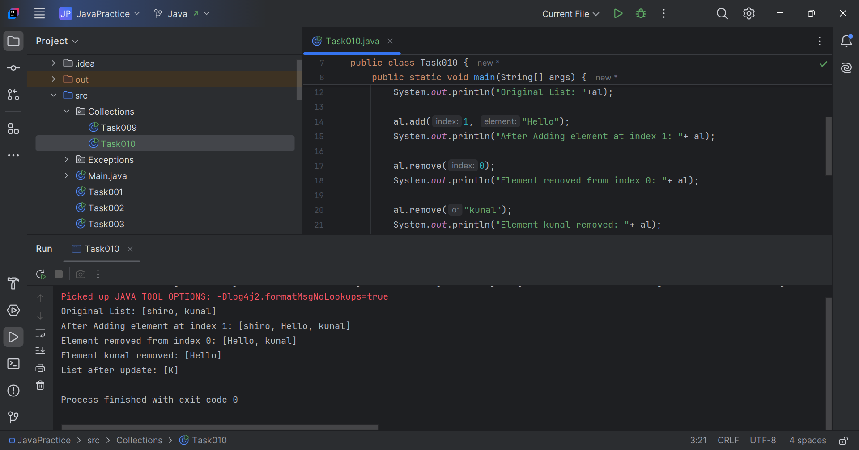

// Task011: Nested classes.  
  
package Collections;  
  
class OuterClass {  
 public static InnerClass *InnerClass*;  
 int x = 10;  
 OuterClass(int x){  
 this.x = x;  
 }  
  
 public class InnerClass {  
 int y = 5;  
 InnerClass(int y){  
 this.y = y;  
 }  
 }  
}  
  
public class Task011 {  
 public static void main(String[] args) {  
 OuterClass outerClass = new OuterClass(10);  
 OuterClass.InnerClass innerClass = outerClass.new InnerClass(8);  
 System.*out*.println(outerClass.x+innerClass.y);  
 }  
}

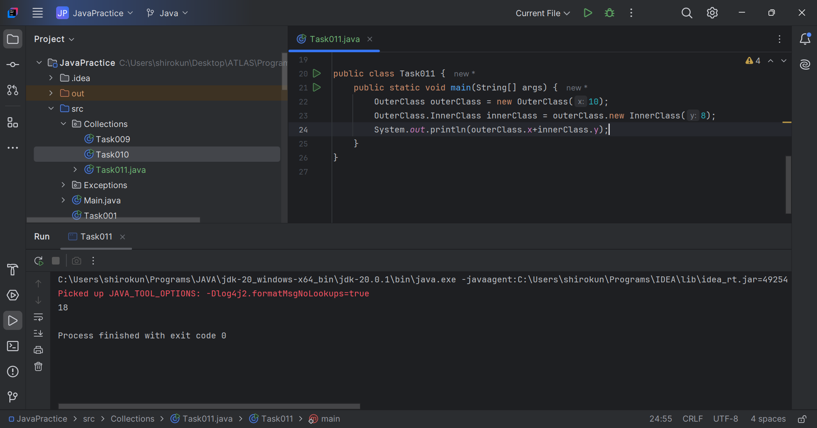

// Task011: Nested classes.  
package Collections;  
  
class University{  
 private final String name;  
 public University(String name) {  
 this.name = name;  
 }  
  
 private class Department {  
 private final String departmentName;  
  
 public Department(String departmentName) {  
 this.departmentName = departmentName;  
 }  
 public void printInfo() {  
 System.*out*.println("University: " + University.this.name);  
 System.*out*.println("Department: " + departmentName);  
 }  
 }  
  
 public void createDepartment(String departmentName) {  
 Department department = new Department(departmentName);  
 department.printInfo();  
 }  
}  
  
public class Task012 {  
 public static void main(String[] args) {  
 String uni = "IIIT Kottayam";  
 String dept = "CSE";  
 University university = new University(uni);  
 university.createDepartment(dept);  
 }  
}

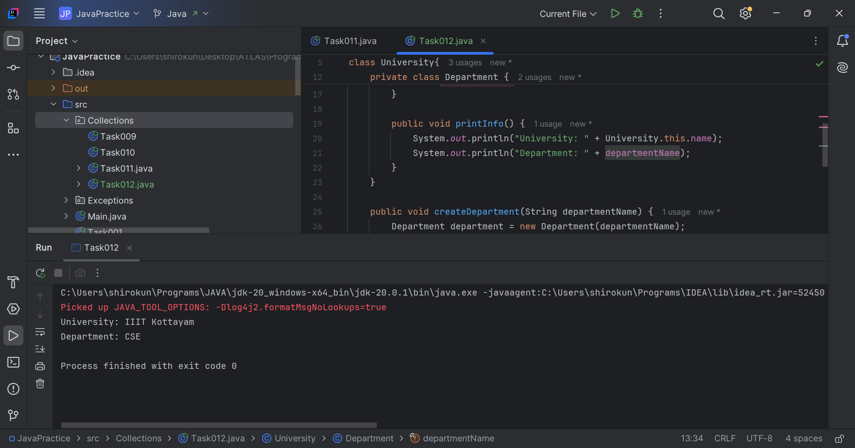

// Task013: Static inner class  
  
package Collections;  
  
class College{  
 String name;  
 College(String name){  
 this.name = name;  
 }  
 static class Section{  
 String secName;  
 int secStrength;  
 Section(String name, int strength){  
 this.secName = name;  
 this.secStrength = strength;  
 }  
 void display(){  
 System.*out*.println(secName+"\t"+secStrength);  
 }  
 }  
 void display(){  
 System.*out*.println("College: "+ name);  
 }  
}  
  
public class Task013 {  
 public static void main(String[] args) {  
 String clg = "Sri Chaitanya", sec = "SEB";  
 int total = 90;  
 College college = new College(clg);  
 College.Section section = new College.Section(sec, total);  
 college.display();  
 section.display();  
 }  
}

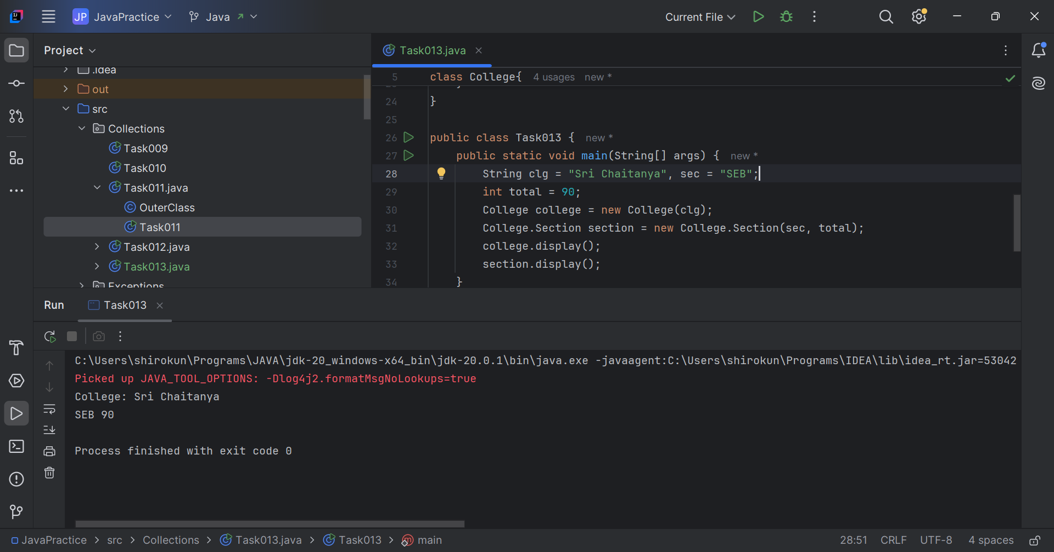

// Task014: Return the outer class method.  
  
package Collections;  
  
class Department{  
 String deptName;  
 Department(String name){  
 this.deptName = name;  
 }  
 class Batch{  
 void display(){  
 System.*out*.println(deptName);  
 }  
 }  
}  
  
public class Task014 {  
 public static void main(String[] args) {  
 String deptName = "SHIELD";  
 Department department = new Department(deptName);  
 Department.Batch batch = department.new Batch();  
 batch.display();  
 }  
}

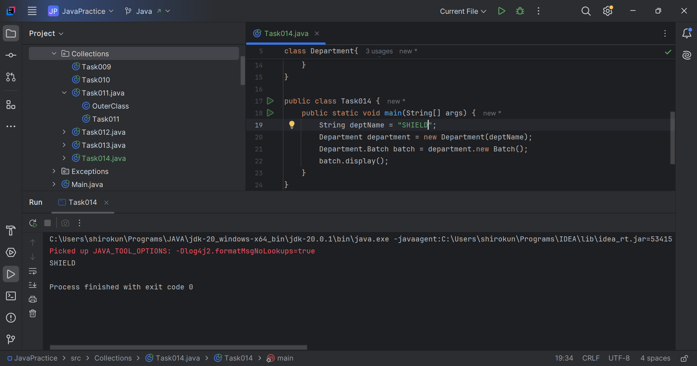

// Task015:  
  
package Collections;  
  
class Outer {  
 int x = 10;  
 static class InnerClass {  
 static int *y* = 5;  
 }  
}  
  
public class Task015 {  
 public static void main(String[] args) {  
 Outer.InnerClass innerClass = new Outer.InnerClass();  
 System.*out*.println(innerClass.*y*);  
 }  
}

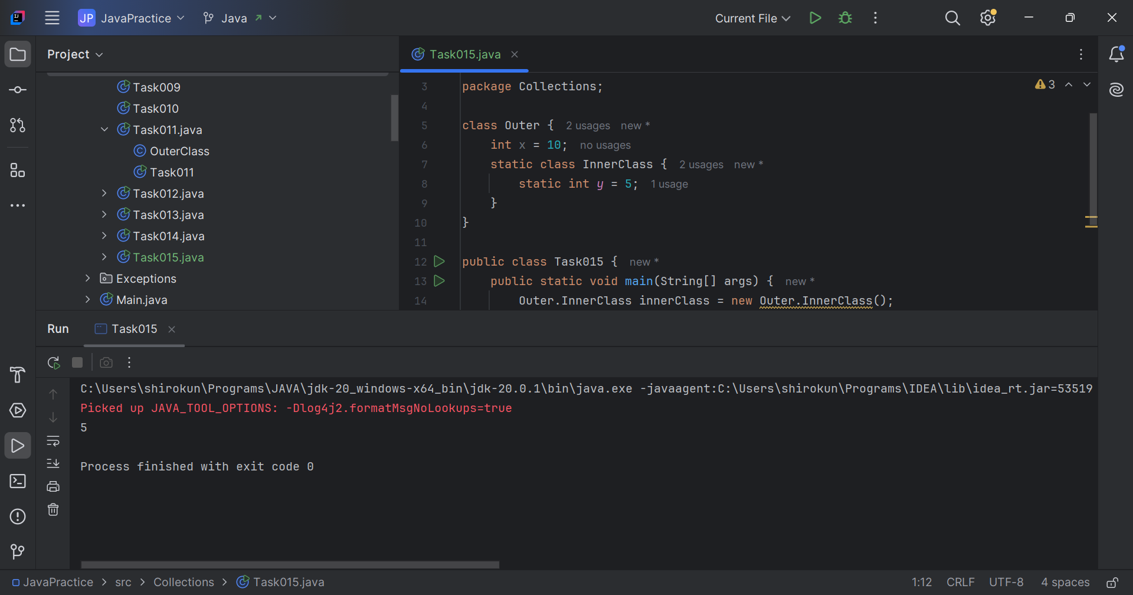

Task 17. What are the features of Java 8?  
Ans: Java 8 Features –

* Lambda Expressions
* Functional Interfaces
* Introduced and Improved APIs
* Stream API
* Date/Time API
* Optional Class
* forEach() Method in Iterable Interface
* Static Methods
* Method References

// Task018:  
  
package Collections;  
  
import java.util.ArrayList;  
import java.util.List;  
import java.util.function.Consumer;  
import java.lang.Integer;  
  
class MyConsumer implements Consumer<Integer>{  
  
 public void accept(Integer t) {  
 System.*out*.println("Consumer impl Value::"+t);  
 }  
}  
  
public class Task018 {  
 public static void main(String[] args) {  
 List<Integer> myList = new ArrayList<>();  
 for(int i=0; i< 10; i++){  
 myList.add(i);  
 }  
  
 for (Integer i : myList) {  
 System.*out*.println("Iterator Value::" + i);  
 }  
  
 myList.forEach(t ->  
 System.*out*.println("forEach anonymous class Value::"+t));  
  
 MyConsumer action = new MyConsumer();  
 myList.forEach(action);  
 }  
}

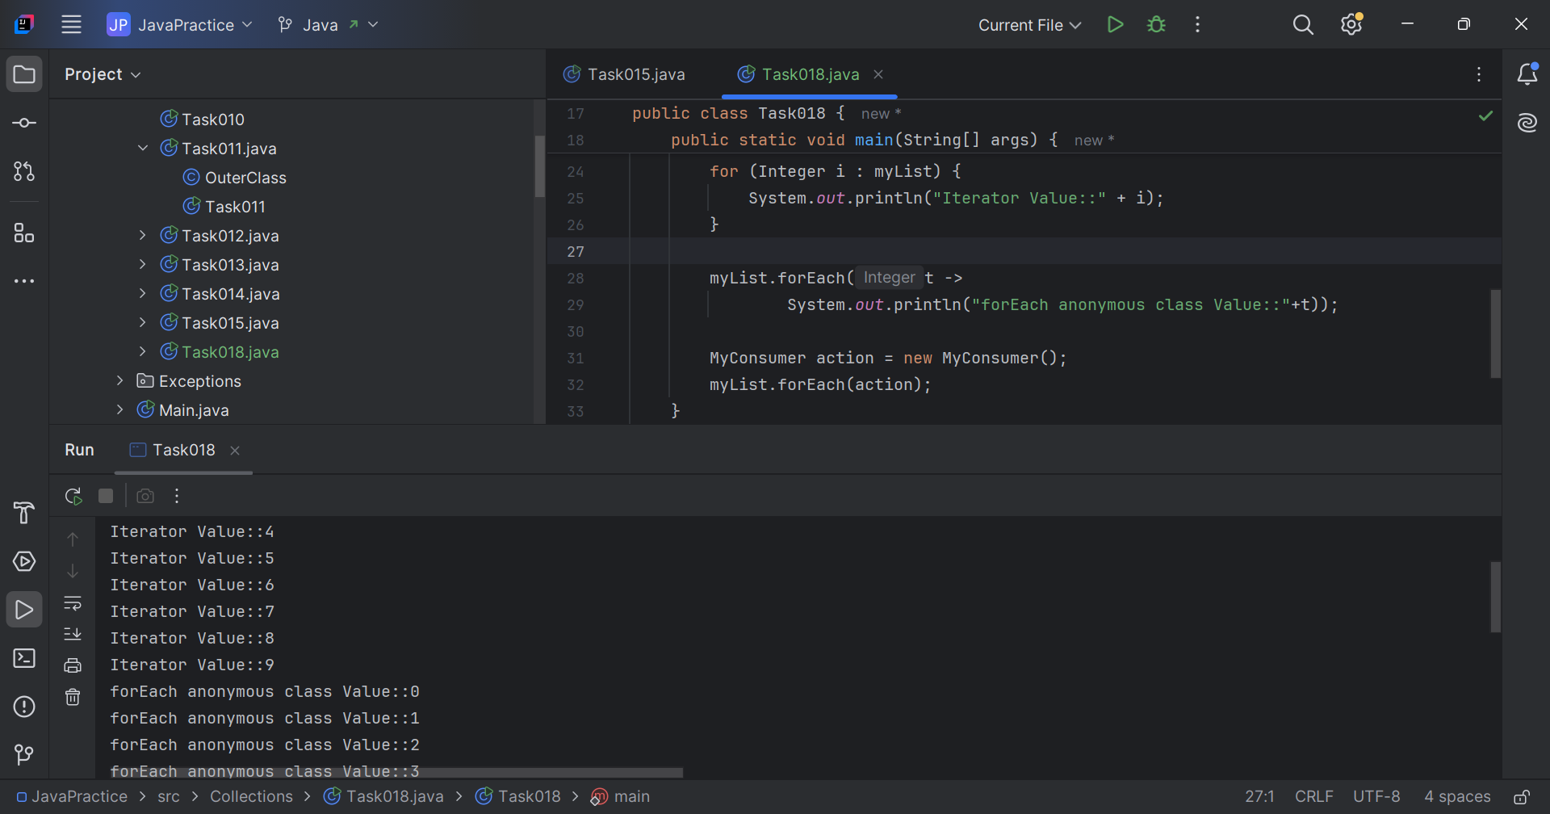

// Task020: Collections.  
  
package Collections;  
  
import java.util.\*;  
  
public class Task020 {  
 public static void main(String[] args) {  
 // ArrayList  
 List a1 = new ArrayList();  
 a1.add("Zara");  
 a1.add("Mahnaz");  
 a1.add("Ayan");  
 System.*out*.println(" ArrayList Elements");  
 System.*out*.print("\t" + a1);  
  
 // LinkedList  
 List l1 = new LinkedList();  
 l1.add("Zara");  
 l1.add("Mahnaz");  
 l1.add("Ayan");  
 System.*out*.println();  
 System.*out*.println(" LinkedList Elements");  
 System.*out*.print("\t" + l1);  
  
 // HashSet  
 HashSet s1 = new HashSet();  
 s1.add("Zara");  
 s1.add("Mahnaz");  
 s1.add("Ayan");  
 System.*out*.println();  
 System.*out*.println(" Set Elements");  
 System.*out*.print("\t" + s1);  
  
 // HashMap  
 Map m1 = new HashMap();  
 m1.put("Zara", "8");  
 m1.put("Mahnaz", "31");  
 m1.put("Ayan", "12");  
 m1.put("Daisy", "14");  
 System.*out*.println();  
 System.*out*.println(" Map Elements");  
 System.*out*.print("\t" + m1);  
  
 }  
}

